Project Report

on

**“Analysis Of TOR Network”**

CYB

Secure Data Communications and Networks.

Team Members:

Prajakta Bharat Meher

Rusheel Raj Panakadan

**ACKNOWLDGEMENT**

It is indeed a matter of great pleasure and privilege to be able to present this project on **“Analysis of TOR Network”**.

We would like to express our deep regards and gratitude to the Instructor **Dr. Abdullah Aydeger.**

The completion of this project work is a milestone in a student life and its execution is inevitable in the hands of a guide. We are highly indebted to the project guide Dr. Abdullah Aydeger for his invaluable guidance and appreciation for giving form and substance to this project. It is due to his enduring efforts, patience and enthusiasm, which has given a sense of direction and purposefulness to this project and ultimately made it a success.

We would like to thank our friends who have helped us all the time.

**ABSTRACT**

The TOR (The Onion Router) network project is a decentralized and anonymous communication system that allows users to browse the internet without revealing their location or identity. It works by routing internet traffic through a network of volunteer-run servers, making it difficult for anyone to trace the origin of the traffic. The project was created to protect the privacy and freedom of speech of individuals and organizations, particularly those in countries where internet censorship and surveillance are prevalent. Despite controversy surrounding its use by criminal elements, the TOR network continues to serve as a valuable tool for journalists, activists, and individuals seeking to communicate and access information securely and privately.

The main principle of this project is to show some basic working principles of TOR (The Onion Router) as well as how to configure it manually and automatically and how we can host our own website on TOR network. To execute the same, we used kali Linux and TOR browser.

**Contents**

CHAPTER-1 ……………………………………………………………….……………………..01

INTRODUCTION……………………………………………………….……………………..01

CHAPTER-2 …………………………………………………………………….………………..03

What is Onion Routing ……………………………………………………….……..................03

CHAPTER-3………………………………………………………………………….……………04

    Types of chains in the TOR network ...…………………………………………….…………...04

* Static Chain …...………………………………………….…………. 04
* Dynamic Chain.………………………………………….…………....05
* Round Robin Chain.……..………………………………..…………...07
* Random Chain …………...…………………………….….…………..08

Difference between round robin chaining and random chaining …….………….……………...09

CHAPTER-4……………………………………………………………………………………….10

    What are SOCKS Proxies………………………………………………...…………………….10

CHAPTER-5……………………………………………………………………………………….12

    Configuration Of TOR Network……………………………………………...…………………12

CHAPTER-6……….………………………………………………………………………………14

    Network Traffic Analysis ……..…………………………...…………………...……………….14

CHAPTER-7……..…………………………………………………………………………………20

Tor Status Code………..…………………………...……………………………………………20

CHAPTER-8……….……………………………………………………………………………… 22

Proxy Chain …………………………………………………………………………................ 22

CHAPTER-9………….…………………………………………………………………………… 27

Hosting TOR Website …………………………………………………………………………. 27

CHAPTER-10……………………………………………………………………………………... 34

Network Traffic Analysis of a real pcap network capture of TOR………………………………34

CHAPTER-11……………………………………………………………………………………… 42

Conclusion…….…………………………………………………………………………………. 42

References ………………………………………………………………………………………  42

**CHAPTER-1**

**INTRODUCTION**

The Onion Router (TOR) is a free and open-source software project that allows users to surf the web anonymously. It operates by routing internet traffic through a global network of volunteer-run servers called nodes or relays. TOR works by encrypting and relaying network traffic over a network of nodes numerous times. Each node only knows the identities of the nodes preceding and following it in the chain, as well as the end destination, making it difficult for anyone to trace the traffic back to its origin. This multi-layered encryption and routing technique is commonly known as "onion routing."

People who want to protect their online privacy or access content that is blocked in their region frequently use TOR. Journalists, activists, and whistleblowers utilize it to interact with sources and safely transmit sensitive information. It should be noted, however, that TOR can also be used for unlawful purposes, such as buying and selling illegal goods on the dark web.

Using Tor makes it more difficult to trace a user's Internet activity. Tor's system architecture aims to deliver both high levels of anonymity and stringent performance standards. Tor currently provides an anonymity layer for TCP by carefully creating a three-hop path (by default) or circuit through the Tor router network using a layered encryption method akin to onion routing. A group of authoritative directory servers distributes routing information. In general, all TCP connections from a single client are tunneled over a single circuit that rotates over time. A circuit normally has three hops: the first node in the circuit is known as the entry Tor router, the middle node is known as the middle Tor router, and the final hop in the circuit is known as the exit Tor router.

It’s the Onion Routing protocol. In onion routing, the connection is maintained between different nodes. It is because the message we send and the responses we receive are encrypted with different keys, with a unique key for encryption for every different hop or server visit. Tor separates identity and routing in order to conceal its users' identities and online activity from monitoring and traffic analysis. It is an onion routing system that encrypts and then randomly bounces communications around a network of relays run by volunteers all over the world. These onion routers use multi-layered encryption (thus the onion metaphor) to provide perfect forward secrecy between relays, giving users anonymity in a network location. Tor's anonymous onion service capability allows for the hosting of censorship-resistant material. Furthermore, by concealing some of the entry relays (bridge relays), users can avoid Internet censorship based on the blocking of public Tor relays.

Because the sender's and recipient's IP addresses are not both in cleartext at any point along the communication channel, anyone eavesdropping at any point along the way cannot directly identify both ends. Furthermore, the last Tor node (called the exit node) appears to the recipient to be the originator of the communication, rather than the sender.

SOCKS-aware apps can be set to route network traffic over the SOCKS interface of a Tor instance, which is listening on TCP port 9050 (for standalone Tor) or 9150 (for Tor Browser bundle) at localhost. Tor builds virtual circuits through the Tor network on a regular basis in order to multiplex and onion-route traffic to its destination. Once inside a Tor network, traffic is routed from router to router along the circuit until it reaches an exit node, where the cleartext packet is available and forwarded to its original destination. The traffic seems to originate from the Tor exit node when viewed from the destination. A non-exit Tor relay with a maximum output speed of 239.69 kbit/s.

**CHAPTER-2**

**The Onion Routing**

Onion Routing works by using a series of relays, each of which decrypts a layer of encryption to reveal the next relay in the circuit. The sender encrypts the data multiple times, with each layer of encryption corresponding to a different relay in the circuit. Each relay only knows the previous and next relay in the circuit, which ensures that no single relay knows the complete path of the data. The TOR network also uses hidden services, which allow website owners to host content anonymously on the TOR network.

Tor can also be used to anonymize websites and other servers. Onion services (previously hidden services) are servers that are configured to only accept inbound connections over Tor.An onion service is accessible by an onion address, rather than revealing a server's IP address (and consequently its network location). The Tor network recognizes these addresses by seeking up their accompanying public keys and introduction points in the network's distributed hash table. It can transport data to and from onion services, even those behind firewalls or network address translators (NAT), while maintaining both parties' anonymity. Tor is required to use these onion services.

Onion services were defined in 2003 and have been used on the Tor network since 2004. Tor is decentralized by design, except for the database that records onion service descriptors; there is no direct readable list of all onion services, albeit a handful of onion services catalog publicly available onion addresses. TorSearch is an internet search engine that indexes pages to aid in the discovery of material on Tor-connected websites.

Because onion services route all their traffic through the Tor network, connections to onion services are encrypted end-to-end and are not vulnerable to eavesdropping. However, there are security concerns with Tor onion services. Services accessible via Tor onion services and the public Internet, for example, are vulnerable to correlation attacks and hence not completely hidden. Misconfigured services (for example, identifying information included by default in web server error messages), uptime and downtime data, intersecting attacks, and user error are all potential problems. Independent security researcher Sarah Jamie Lewis' open source OnionScan tool thoroughly investigates onion services for several problems and vulnerabilities. (Lewis also pioneered the concept of "Onion Dildonics," sex toys that employ Tor via the Ricochet protocol.)

Using services such as Tor2web, onion services can also be accessed from a standard web browser without requiring a client-side connection to the Tor network. Pastebin, Twitter, Reddit, and other Internet forums are popular places to find .onion connections.

**CHAPTER-3**

**Types of chains in the TOR network**

**1.Static chains:**

The path through the network is predetermined and fixed. The user's traffic always takes the same path through the network. Less secure than dynamic chains because an attacker can potentially compromise the nodes in the fixed path and deanonymize the user.

Static chaining, also known as Tor hidden services or rendezvous points, is a Tor network feature that allows two parties to establish a direct and private connection without disclosing their IP addresses to each other or to Tor relays.

The following is how static chaining works:

The party wishing to establish a hidden service (the client) generates a one-of-a-kind public/private key combination and publishes the public key as a Tor onion address. This onion address is a cryptographically secure string that is generated at random from the public key and serves as the endpoint for the hidden service.

The client requests the onion address from the other party who wishes to connect to the hidden service (the service). The client delivers the onion address and a one-time-use secret key to the service, which is referred to as a rendezvous point. The service chooses a random relay in the Tor network to function as the rendezvous point and sends a message encrypted with the rendezvous point's public key to the client. The client receives the encrypted message and delivers it together with its own one-time-use secret key back to the rendezvous point. The rendezvous point decrypts the message, verifies the keys, and creates a secure connection between the client and the service. Tor relays only observe encrypted communication traveling through their nodes and have no knowledge of the parties involved's identities or IP addresses.

Advantages:

Static chaining has the advantage of allowing totally anonymous communication between parties because neither party must divulge their IP address to the other. This is especially important for persons living under repressive regimes who need to communicate with one another without fear of being identified or tracked down.

Another advantage of static chaining is that it is resistant to traffic analysis assaults because Tor relays only view encrypted communication traveling through their nodes and have no knowledge of the people involved' identities or IP addresses.

Disadvantages: However, static chaining has some drawbacks. For example, it may be subject to denial-of-service assaults, in which an attacker floods the Tor network with traffic in an attempt to overwhelm the relays and interrupt the client-service connection. Furthermore, static chaining is vulnerable to end-to-end correlation attacks, in which an attacker monitors traffic at both ends of a connection to determine the identities of the parties involved.

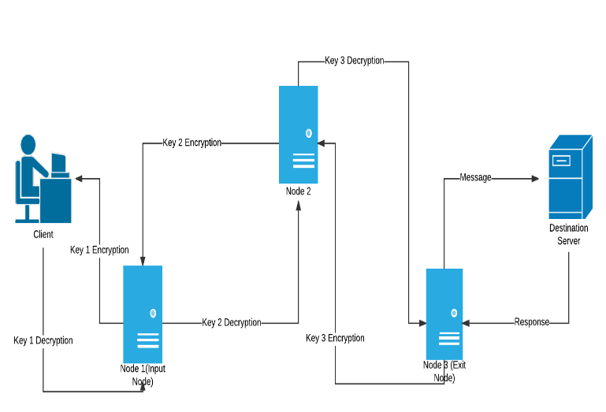

Fig. 1 Static Chain

**2.Dynamic chains:**

The path through the network changes periodically. The user's traffic takes a different path through the network each time it is sent. It is more secure than static chains because they make it harder for an attacker to trace the user's traffic.

Dynamic chaining, also known as circuit-level encryption, is a Tor network feature that sends internet data through a series of randomly selected relays to safeguard the user's privacy and anonymity.

The following is how dynamic chaining works:

Each packet of the user's internet communication is encrypted many times with layers of encryption, one for each relay in the circuit. The user's Tor client chooses an entry relay at random from the pool of accessible Tor relays and creates an encrypted connection with it. The entry relay decrypts the first layer of encryption and forwards the packet to the next relay in the circuit, which decrypts the second layer of encryption and forwards the packet to the next relay, and so on until the final relay in the circuit decrypts the final layer of encryption and sends the packet to its intended internet destination. The response is sent back through the same circuit of relays in reverse order, with each relay decrypting its layer of encryption before sending the packet to the next relay, until the message reaches the user's Tor client.

Advantages:

One advantage of dynamic chaining is that it protects against traffic analysis attacks because each relay in the circuit only knows the identification of the previous and next relay in the circuit but not the origin or destination of the traffic. As a result, it is impossible for an attacker to link the traffic to the user's identity or actions.

Another advantage of dynamic chaining is that it allows users to access websites and services that may be restricted in their region or nation due to the Tor network's ability to circumvent geo-restrictions and censorship.

However, dynamic chaining has some drawbacks. The various levels of encryption and decryption, for example, can slow down the user's internet connection, making it less appropriate for bandwidth-intensive activities like streaming video or playing online games. Furthermore, the Tor network's reliance on a pool of available Tor relays means that it could be compromised if a large number of relays are controlled by a malicious actor. Finally, dynamic chaining lacks end-to-end encryption and is dependent on the user's trust in the exit relay not to intercept or tamper with their internet traffic.

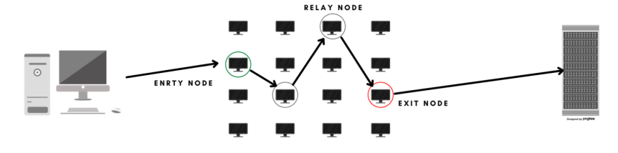

Fig. 2 Dynamic Chain

**3.Round-robin chains:**

The user's traffic takes a path that is randomly selected from a pool of nodes. The user's traffic takes a different path through the network each time it is sent. Similar to dynamic chains in terms of security, but they have the added benefit of evenly distributing the load across the network.

Round robin chaining is a Tor network feature that is intended to increase Tor users' anonymity and security by dispersing their traffic across numerous Tor circuits. Path selection is another name for it.

Round robin chaining works as follows:

The Tor client maintains a pool of accessible Tor relays and selects a new circuit for each new connection or data stream. The selection procedure is round-robin, which means that the first circuit chosen will be used for the first connection, the second circuit for the second connection, and so on until all circuits have been used. When all of the circuits have been exhausted, the selection process is restarted from the beginning of the pool. The circuits are chosen at random from a pool of accessible relays, with each circuit comprised of three relays: an entry relay, a middle relay, and an exit relay. The selected circuit then routes the user's traffic, with each relay decrypting one layer of encryption before transferring the traffic to the next relay in the circuit. When traffic reaches the exit relay, it is decrypted and routed to its final destination on the internet.

Advantages:

Round robin chaining has the advantage of providing additional defense against traffic analysis assaults by dispersing the user's traffic across numerous circuits, making it more difficult for an attacker to correlate the user's activity with their identity. Another advantage of round robin chaining is that it provides redundancy and resilience in the event that one of the circuits becomes damaged or unavailable.

However, round robin chaining has some drawbacks. It can, for example, slow down a user's internet connection due to the additional complexity of selecting and configuring several circuits for each new connection or data stream. Furthermore, the selection process may not always yield the best possible circuit for a given connection, which may result in performance issues or reduced anonymity. Finally, the Tor network's reliance on a pool of available Tor relays means that it could be compromised if many relays are controlled by a malicious actor.

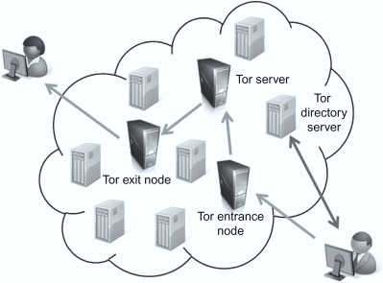

Fig. 3 Round Robin Chain

4.Random chains:

Random chaining, also known as random path selection, is a Tor network feature that is intended to offer Tor users with an additional degree of privacy and anonymity by randomly selecting the relays used in each circuit.

The following is how random chaining works:

The user's Tor client chooses an entrance relay at random from a pool of available Tor relays. The client then chooses a random middle relay from the pool of available relays, eliminating any relays used in the current or previously selected circuits. The client then chooses an exit relay at random from the pool of accessible relays, eliminating any relays used in the current circuit or previously selected circuits.The selected circuit then routes the user's traffic, with each relay decrypting one layer of encryption before transferring the traffic to the next relay in the circuit. When traffic reaches the exit relay, it is decrypted and routed to its final destination on the internet. After using the circuit, the client discards it and selects a fresh set of random relays for the next connection or data stream.

Advantages:

One advantage of random chaining is that it protects against traffic analysis attacks because each circuit is chosen at random and does not follow a predictable pattern. Another advantage of random chaining is that it provides redundancy and resilience in the event that one of the circuits becomes corrupted or unavailable.

However, random chaining has some drawbacks. It can, for example, slow down a user's internet connection due to the additional overhead of selecting and configuring a new circuit for each new connection or stream of data. Furthermore, the random selection process may not always produce the best possible circuit for a given connection, which may result in performance issues or reduced anonymity. Finally, the Tor network's reliance on a pool of available Tor relays means that it could be compromised if a large number of relays are controlled by a malicious actor.

**Difference between round robin chaining and random chaining:**

|  |  |  |
| --- | --- | --- |
| **Feature** | **Round Robin Chaining** | **Random Chaining** |
| Selection Process | Round-robin selection from a pre-defined pool of relays | Random selection from the pool of available relays |
| Circuit Consistency | Consistent circuit selection for each new connection/stream | New circuit selected for each new connection/stream |
| Overhead | Additional overhead due to the selection of multiple circuits for each new connection/stream | Additional overhead due to the selection of a new circuit for each new connection/stream |
| Predictability | Can be somewhat predictable in terms of circuit selection | Completely unpredictable in terms of circuit selection |
| Resiliency | Provides redundancy and resiliency by distributing traffic across multiple circuits | Provides resiliency by selecting new circuits for each connection/stream |
| Anonymity | Provides some additional anonymity by distributing traffic across multiple circuits | Provides strong anonymity by using a completely random selection process |
| Performance | Can potentially lead to performance issues due to suboptimal circuit selection | Can potentially lead to slower performance due to the selection of a new circuit for each connection/stream |
| Security | Can potentially be compromised if a large number of relays are controlled by a malicious actor | Can potentially be compromised if a large number of relays are controlled by a malicious actor |

Table 1 : Difference between round robin chaining and random chaining

In essence, the primary distinction between round robin and random chaining lies in the selection procedure. Round robin chaining chooses circuits in a predictable, round-robin method from a pre-defined pool of relays, whereas random chaining chooses circuits at random from the pool of available relays, resulting in an entirely unexpected circuit selection process. Both techniques have advantages and disadvantages, and the choice between the two is largely determined by the Tor user's individual needs and objectives.

**CHAPTER-4**

**What is SOCKS proxy?**

It stands for Socket Secure Proxy. It is a network protocol that enables communication with servers located behind a firewall by redirecting network traffic to the intended server on behalf of the client. It creates a Transmission Control Protocol (TCP) connection to another server behind the firewall on the client’s behalf, then exchanges network packets between the client and the actual server.

A SOCKS (Socket Secure) proxy is a sort of proxy server that allows a client to connect to a remote server over the internet in a secure and anonymous manner. SOCKS proxies operate at the OSI model's transport layer (Layer 4) and provide a generic proxying method for any application protocol that uses TCP or UDP as its transport protocol.

SOCKS proxying operates as follows:

The client connects to the SOCKS proxy server and requests a connection to a remote server. The SOCKS proxy server connects to the distant server on the client's behalf. To ensure end-to-end security, the proxy server passes data between the client and the distant server, decrypting and re-encrypting data as needed. The client routes all of its traffic through the SOCKS proxy server, which relays it to the distant server. All traffic from the remote server is sent back to the proxy server, which then passes it to the client. The client and distant server communicate as though they were directly linked, with no knowledge of the proxy server's presence.

SOCKS4 and SOCKS5 are the two versions of the SOCKS protocol that are extensively used in Tor. Here's a technical breakdown of each:

SOCKS4: SOCKS4 is a legacy SOCKS protocol that only supports TCP traffic.

It has the following characteristics:

* IPv4 addresses are the only ones supported.
* There is no authentication mechanism provided.
* Does not allow UDP traffic; only the CONNECT and BIND techniques are supported.

SOCKS5: SOCKS5 is a more advanced version of the SOCKS protocol that adds new functionality and security.

It has the following characteristics:

* IPv4 and IPv6 addresses are supported.
* Provides a variety of authentication mechanisms, including username/password and GSS-API (Kerberos) authentication.
* TCP and UDP traffic are supported.
* Provides more advanced authentication mechanisms such as UDP ASSOCIATE and GSS-API.
* TLS (Transport Layer Security) can potentially be used to encrypt traffic between the client and the proxy server.

Tor supports both SOCKS4 and SOCKS5, however SOCKS5 is the preferred version. The usage of SOCKS proxies in Tor has various advantages, including:

Anonymity: SOCKS proxies can be used to mask the client's IP address, making it more difficult to track their online behavior.

SOCKS proxies can be used to circumvent firewalls and other restrictions imposed by network administrators or internet service providers.

Increasing privacy and security: SOCKS proxies can encrypt traffic between the client and the proxy server, adding an extra degree of privacy and security.

SOCKS proxies, on the other hand, have limits and potential vulnerabilities. SOCKS proxies do not encrypt communication by default, making them vulnerable to traffic analysis attacks. Furthermore, the use of a proxy server can add latency and affect performance. It is critical to utilize SOCKS proxies wisely and with prudence.

**CHAPTER-5**

**Configuration of TOR network**

The TOR network is accessible via the TOR Browser, a customized version of the Mozilla Firefox browser that provides additional security and privacy capabilities to ensure users' online anonymity. A step-by-step instruction to setting and using TOR Browser is available here:

* Download and install the TOR Browser from the TOR Project's official website (https://www.torproject.org/). Windows, Mac OS X, and Linux are all supported by the browser.
* Launch the TOR Browser after it has been installed. The browser will connect to the TOR network automatically and display the TOR Browser homepage.
* To configure the TOR Browser settings, pick "Options" from the three-line menu icon in the top-right corner of the browser window.
* You can configure numerous security, privacy, and browsing parameters in the Options menu. Consider the following key settings:

Security level: TOR Browser features a security slider that allows you to choose between various levels of security. Higher security settings safeguard against internet monitoring but may impair website functioning.

Privacy settings: TOR Browser offers a number of privacy settings that can help you maintain your online anonymity, such as disabling third-party cookies, banning tracking scripts, and blocking WebGL.

Proxy configuration: The TOR Browser offers built-in support for SOCKS proxies, which can be used to improve privacy and security. By selecting "Settings" from the Network Proxy section, you can configure the browser to utilize a specified proxy server.

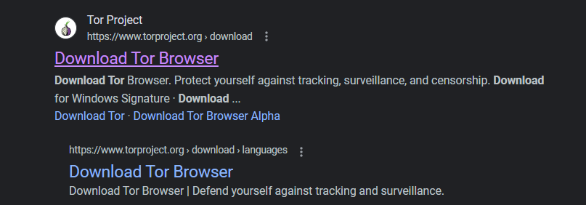

Fig 4. How to Download the TOR

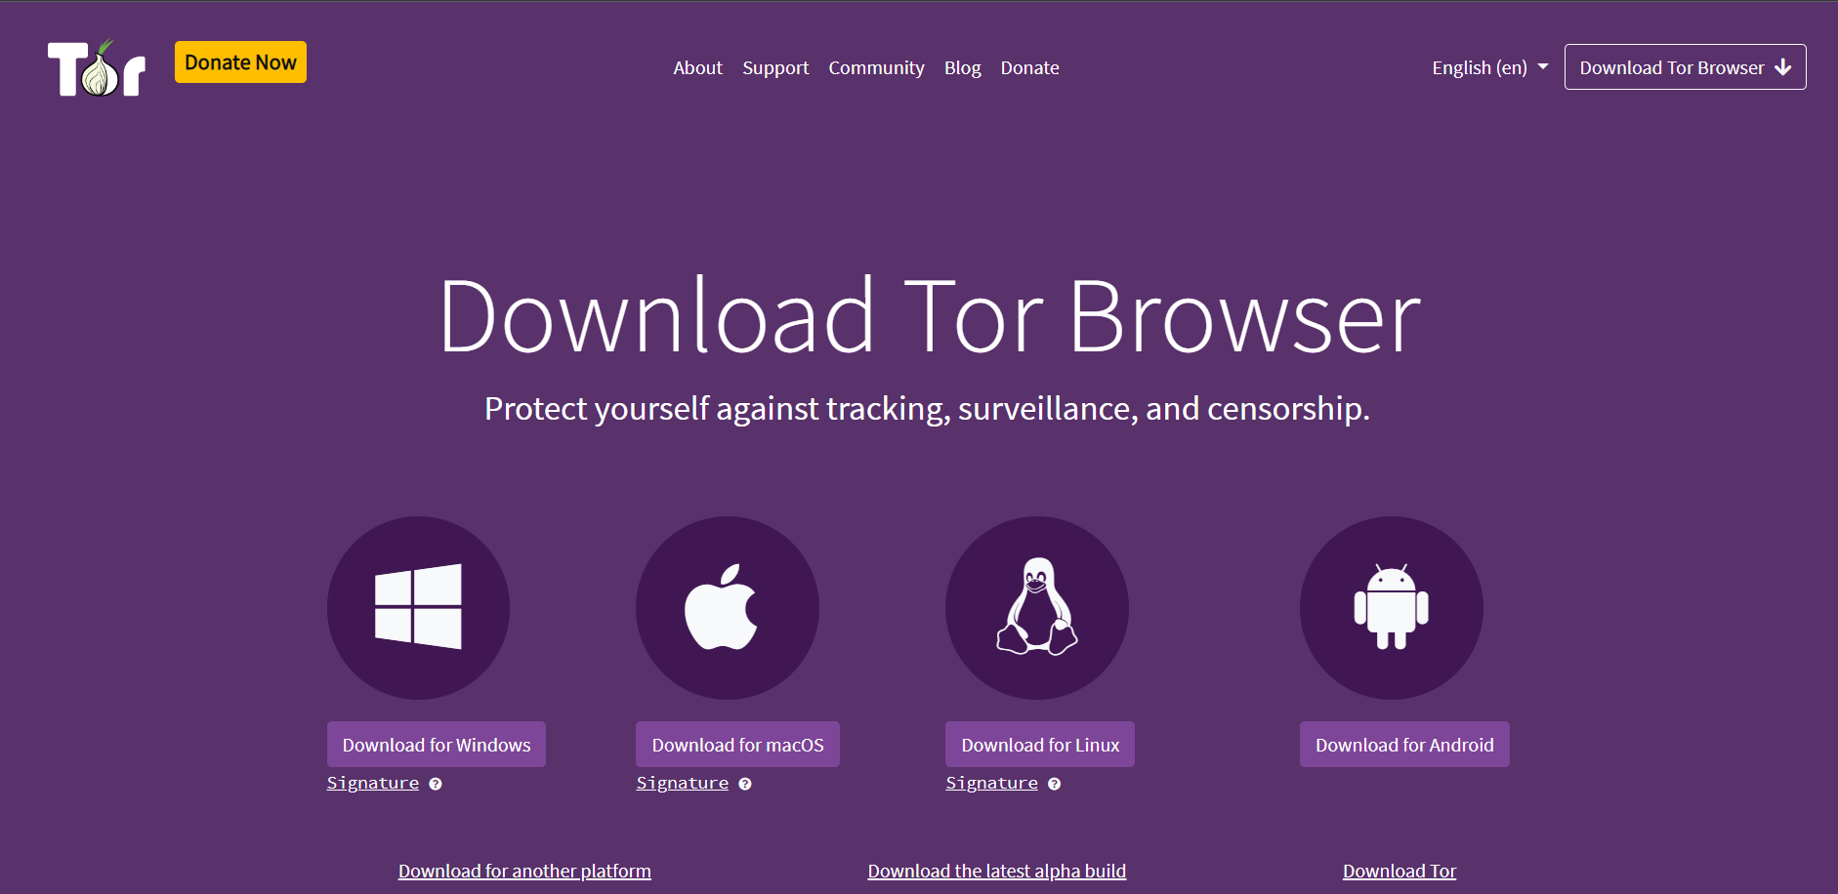

Fig 5. Tor available for different OS

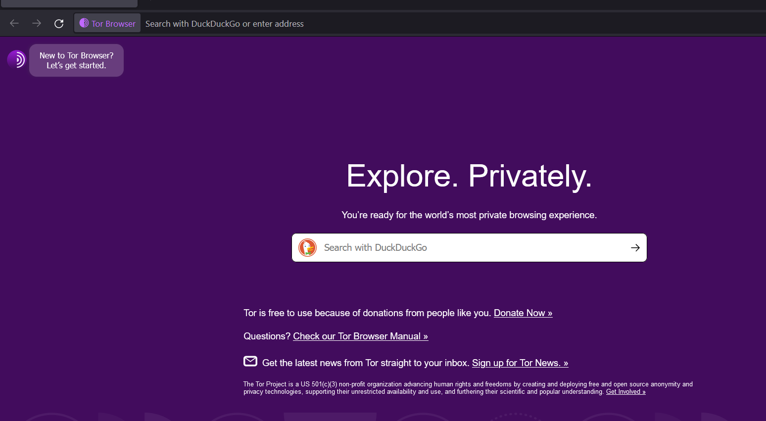

Fig 6. Tor Browser

**CHAPTER-6**

**NETWORK TRAFFIC ANALYSIS**

Once Tor browser is installed or configured, we can search a sample tor search engine site. This ensures we have connected to the Tor network without any issues.

Example of onion search engine:

<http://juhanurmihxlp77nkq76byazcldy2hlmovfu2epvl5ankdibsot4csyd.onion/>

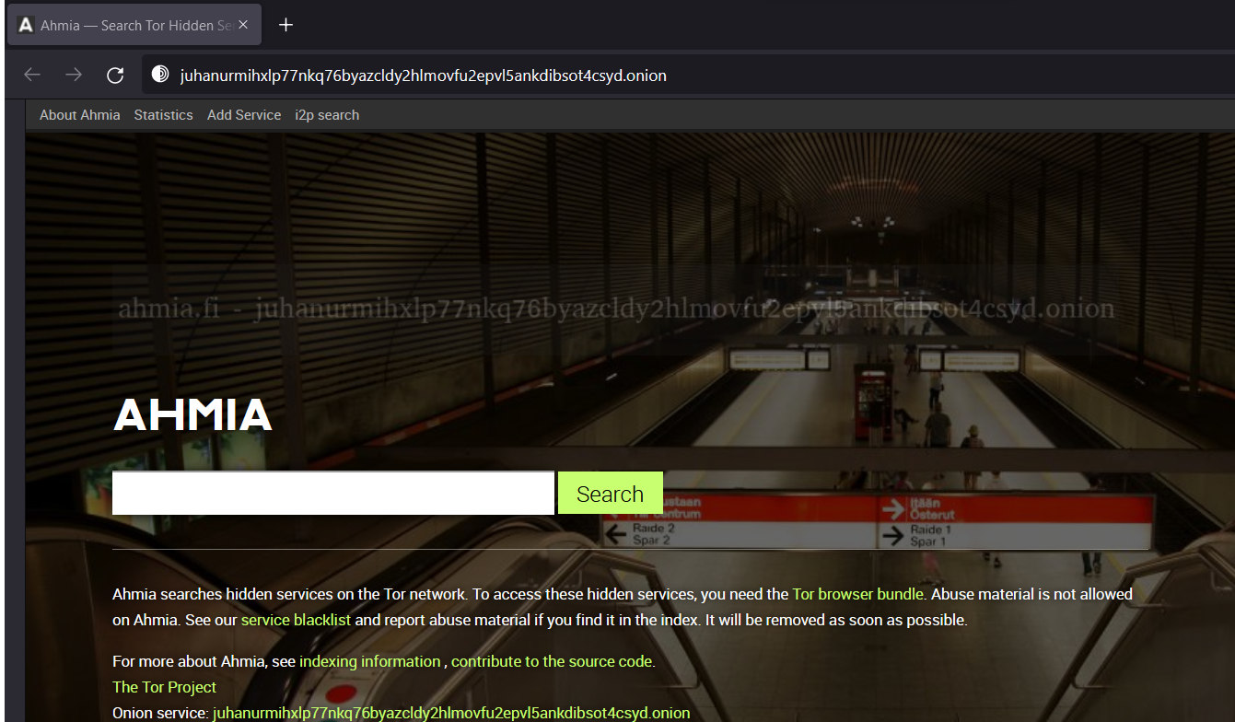

Fig 7. Access AHMIA site

Let’s perform some network traffic analysis of HTTP Onion website and HTTPS onion website and check their working.

Initially for the analysis, we are using TOR browser to visit the onion website, whereas for the network packet capture, we are using Wireshark. Wireshark is a free and open-source network traffic analyzer that allows users to record, analyze, and debug network data. Network administrators, security professionals, and developers use it extensively to monitor and analyze network traffic, solve network issues, and perform security analysis.

Wireshark captures and analyzes data packets as they travel across a network. It supports numerous network protocols, including Ethernet, Wi-Fi, TCP, UDP, HTTP, and others. Users can capture packets in real time or from a previously captured file, and then examine the data using a range of built-in analytic tools.

Step – 1: Start the packet capture by navigating to Capture > Start. This should start to capture all live network packets in the network.

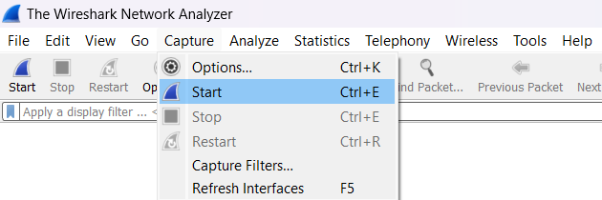

Fig 8. Wireshark Analyzer

Step – 2: Launch the Tor browser and try visiting the onion site of ahmia.fi. The onion site is (<http://juhanurmihxlp77nkq76byazcldy2hlmovfu2epvl5ankdibsot4csyd.onion/>)

Step – 3: We can observe all network traffic which includes traffic like DNS, ARP, TCP, UDP and more. In this case, our search is limited to HTTP because the website we visited is a HTTP website, and we aren’t interested with DNS or ARP data packets.

Step – 4: When analyzing, we can observe the HTTP request sent. All information like HTTP host, user-agent and importantly the request method. We can view this only because it’s unencrypted.

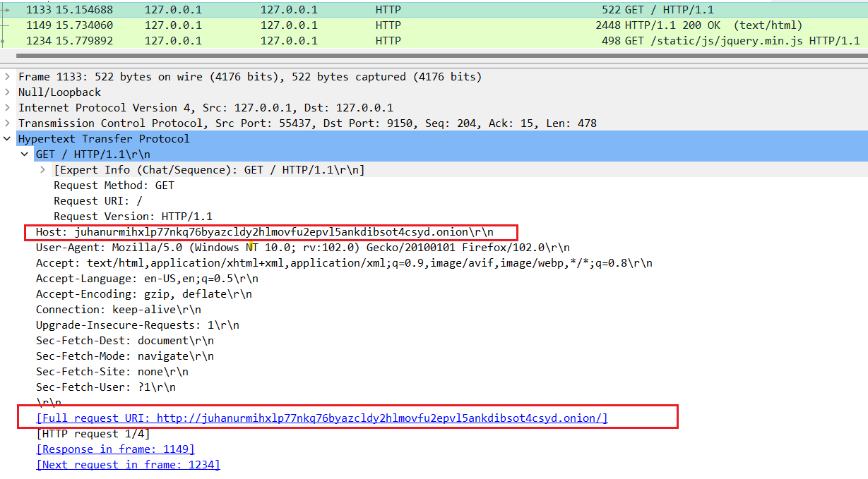

Fig 9. http traffic analysis using Wireshark

Step – 5: When the response is received, upon analyzing, we can observe critical information like Response version of HTTP to be 1, status code is 200, Server is nginx along with its version 1.18, and Content-Type is text/html.

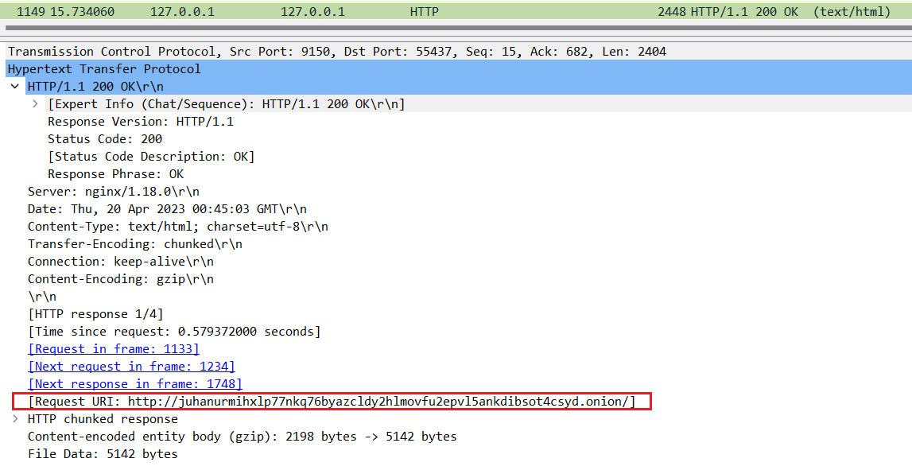

Fig10. http traffic analysis using Wireshark.

Step – 6: To exactly look at how the HTML response looks like, wireshark has a feature to extract the HTML page from the HTTP packet traffic. All we have to do is right click on the response packet, navigate to “Follow” > “HTTP Stream” and this displays the HTML page. Below image is the result of analysis.

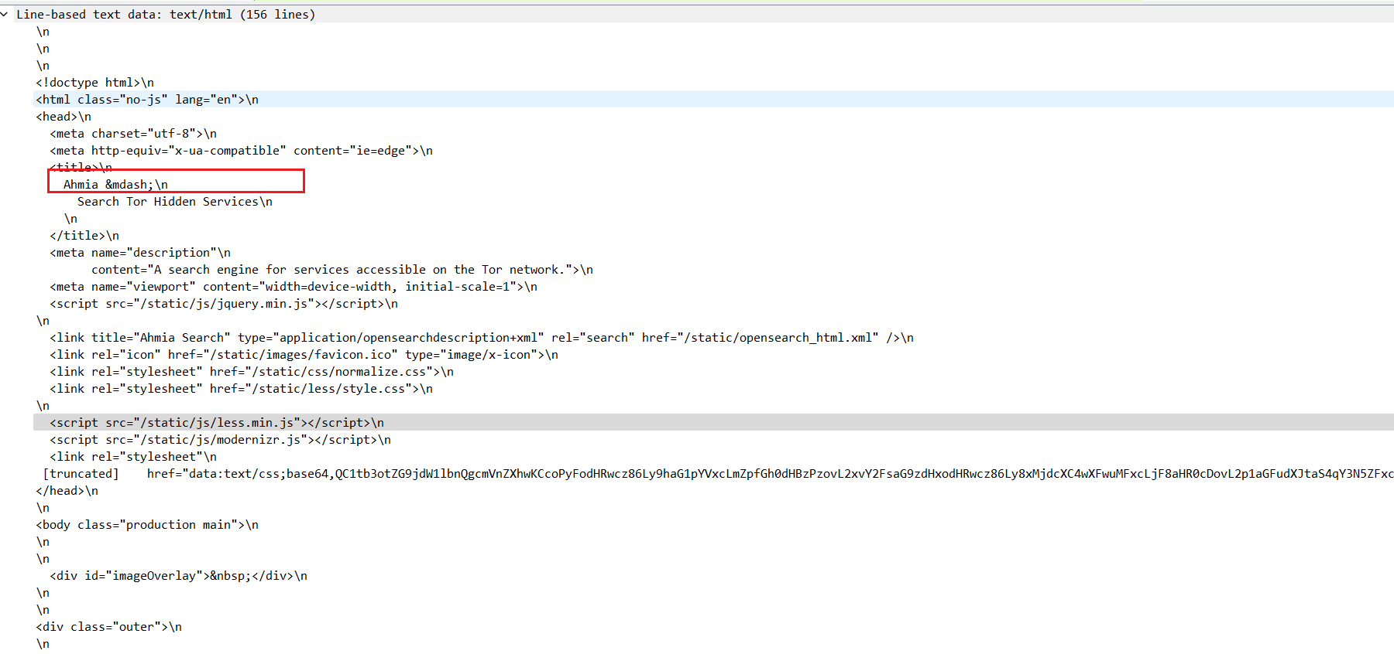

Fig11. Website details

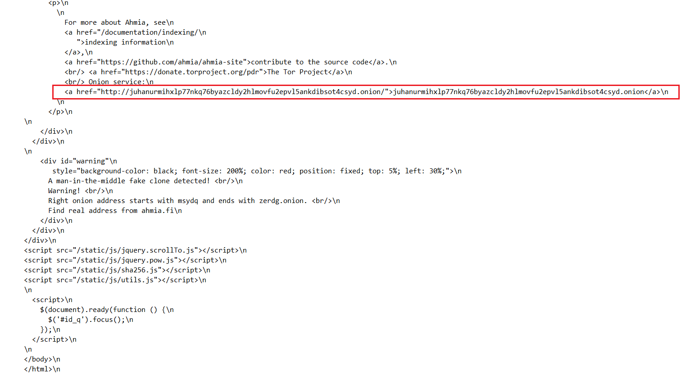

Fig 12. Website details

Step – 7: Similarly, let us check the HTTPS website. This time we are visiting a secured onion search engine called “DuckDuckGo”.

The onion site URL is

“<https://duckduckgogg42xjoc72x3sjasowoarfbgcmvfimaftt6twagswzczad.onion/>”

Filter only HTTP packets to view the traffic. Fortunately, you will not find any HTTP packets in the capture of this onion site because the duckduckgo onion site is using HTTPS over the connection.

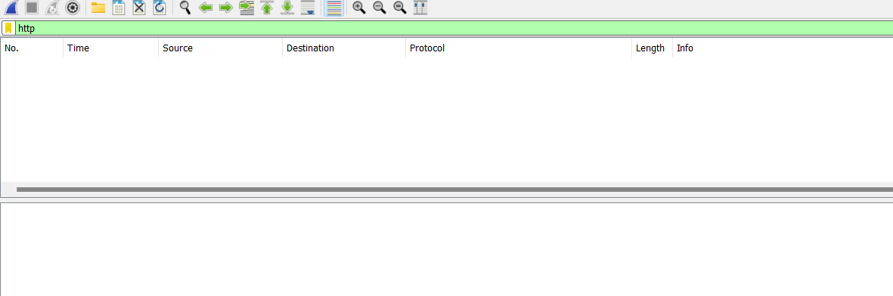

Fig13. https traffic analysis using Wireshark.

The below image is the HTTPS onion site which we visited for the analysis.

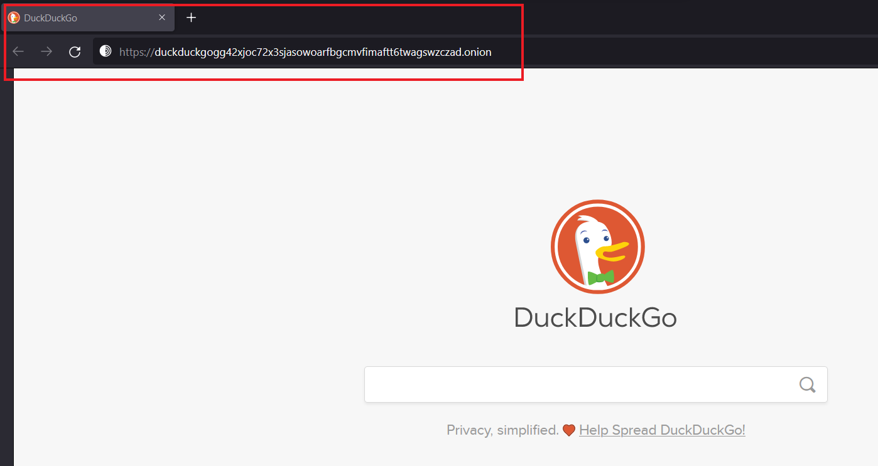

Fig .14 HTTPS onion site

**Why the traffic routes to and from 127.0.0.1?**

When a user opens the Tor Browser, a local proxy server is automatically created on their computer. This proxy server is called the Tor client and it listens on port 9050 for incoming SOCKS connections. The Tor client is responsible for forwarding the user's requests to the Tor network and receiving responses from the network.

When a user enters a website address in their web browser and hits enter, the request is sent to the Tor client on their computer. The Tor client then creates a circuit, which is a series of randomly selected Tor nodes that will be used to forward the user's request to the destination website. The circuit consists of three relays - an entry relay, a middle relay, and an exit relay.

The entry relay is the first relay in the circuit, and it receives the encrypted request from the Tor client. The entry relay then decrypts the request and passes it on to the middle relay. The middle relay does not know the identity of the user who made the request or the destination website, as this information is encrypted. The middle relay only knows the identity of the entry relay and the exit relay in the circuit.

The exit relay is the final relay in the circuit, and it receives the decrypted request from the middle relay. The exit relay then sends the request to the destination website on behalf of the user. The response from the website is then sent back to the exit relay, which encrypts it and sends it back to the user through the same circuit.

By routing the user's request through a series of Tor nodes, the user's IP address and location are hidden from the destination website. The website only sees the IP address and location of the exit relay, which is one of the randomly selected Tor nodes in the circuit.

The use of the local host address (127.0.0.1) for routing is important for security reasons. By default, the Tor client only accepts connections from the same computer, which means that only applications running on the user's computer can use the Tor network. This prevents external applications or attackers from intercepting or tampering with the user's Tor traffic.

In summary, the use of the localhost address (127.0.0.1) for routing in Tor creates a local proxy server on the user's computer that is responsible for forwarding requests to the Tor network. The requests are encrypted and sent through a series of randomly selected Tor nodes before reaching the destination website, which helps to protect the user's privacy and anonymity.

**CHAPTER-7**

**TOR status codes**

Tor employs a series of status codes to communicate the current state of the Tor network. These status codes are intended to assist users and developers in understanding what is going on in the network and diagnosing any faults or mistakes that may arise.

Here are some of the most common Tor status codes, along with detailed explanations:

The status code 250 OK indicates that the requested action was successful. For example, if a user requests a new circuit from a Tor relay, the relay may answer with a "250 OK" status code to signify that the circuit has been formed.

251 Inconsistent arguments: This indicates that the arguments passed to the command were invalid or inconsistent.

420 Unknown command: This indicates that the command requested is not recognized by the Tor control protocol.

421 Unrecognized commands: This indicates that the command requested is recognized, but not valid in this context.

430 Invalid argument: This indicates that one or more of the arguments provided to the command are invalid.

510 Unrecognized addresses: This indicates that the address provided is not valid or recognized by the Tor network.

551 Unrecognized command - This status number indicates that the Tor relay did not recognize the given command. This can happen if the user delivers a command that the relay does not support, or if the command is faulty or incomplete.

552 This status number indicates that the requested command has not been implemented by the Tor relay. This indicates that the relay recognizes the command, but it is not currently supported or available.

650 Stream closed - This status code indicates that the Tor network has closed a stream. This can occur if the user's circuit is severed or if the user's connection to the destination website is lost.

651 Stream failed - This status number indicates that a stream in the Tor network has failed. This can happen if one of the Tor relays in the circuit fails or if there is a network problem that prevents the stream from being finished.

The status code 700 N/A indicates that the requested operation is not applicable in the present environment. For example, if a user sends a request to a Tor relay that is not running a specific type of service, the relay may respond with the status code "700 N/A" to indicate that the service is not accessible.

701 Tor is unable to construct a circuit safely – This status code indicates that Tor is unable to create a circuit for security concerns. This can happen if the user's request cannot be adequately encrypted or if one of the relays in the circuit has a security flaw.

702 Tor rejected - This status code indicates that Tor declined the user's request. This could happen if the user's request breaches Tor's policies or is deemed suspicious or malicious.

703 This status code indicates that the user's request to the Tor relay's proxy server was unsuccessful. This can happen if the user's network connection is down or if the proxy server is not responding.

**CHAPTER-8**

**Proxy chains**

Proxychains is a popular open-source program for running any TCP or UDP application through a proxy server. The utility works by routing network traffic from a user's computer to a proxy server, allowing the user to access the internet or network resources via the proxy server rather than their own IP address. This can be advantageous for a variety of reasons, including circumventing internet limitations and increasing anonymity and privacy.

Step -1: Installing proxychains.

* $ sudo apt install proxychains
* $ sudo apt install proxychains4

Step -2: Configuring proxychains.

Navigate to the /etc folder and open the proxychains4.conf file to edit the configuration changes. Uncomment the type of chaining needed for the proxychains. In our case, we want to test it on dynamic chains. At the bottom of the page, we need to add socks5 layer version for our proxy. Adding this below line to our configuration file would enable us to use SOCKS5 layer for the proxy.

Socks5 127.0.0.1 9050

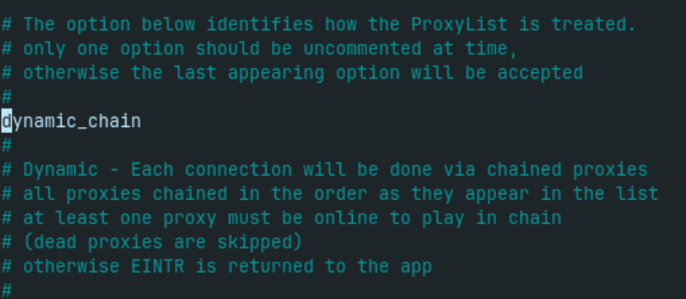

Fig .15 Modifying the proxy chain configuration file

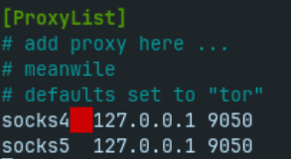

Fig .16 Adding the new SOCKS5 version in the proxy chain configuration file

Step -3: Once the configuration changes are done, open a new terminal window and start the proxchains with a web-browser as well as a website we want to connect. In our case, as we are using proxychains version 4, this is how the command looks like:

$ proxychains4 firefox whatismyipaddress.com

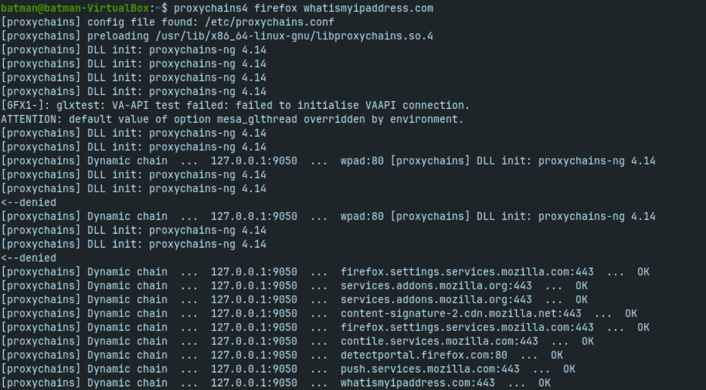

Fig .17 Establishing the network using proxy chains.

Step -4: This is how we can view the proxychains traffic in the terminal. We can notice that the type of chain used in this connection is “Dynamic Chain”, localhost 127.0.0.1 and port 9050 with resulted IP address which we wanted to search. The last column describes the HTTP status code of the http request.

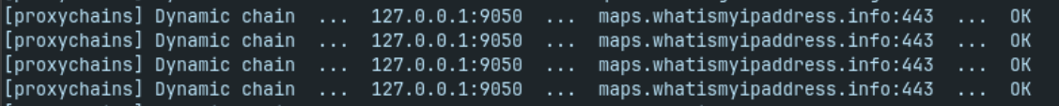

Fig .18 Connection Established successfully using proxy chains.

Step – 5: Let us check whether the traffic is really anonymizing. Online public IP address viewer can help us find out. Once the proxychains is established, we can see that our public IP is completely anonymized. The IP address is at location “Iceland” with a IP address as “89.147.110.214”

Check the IP address.

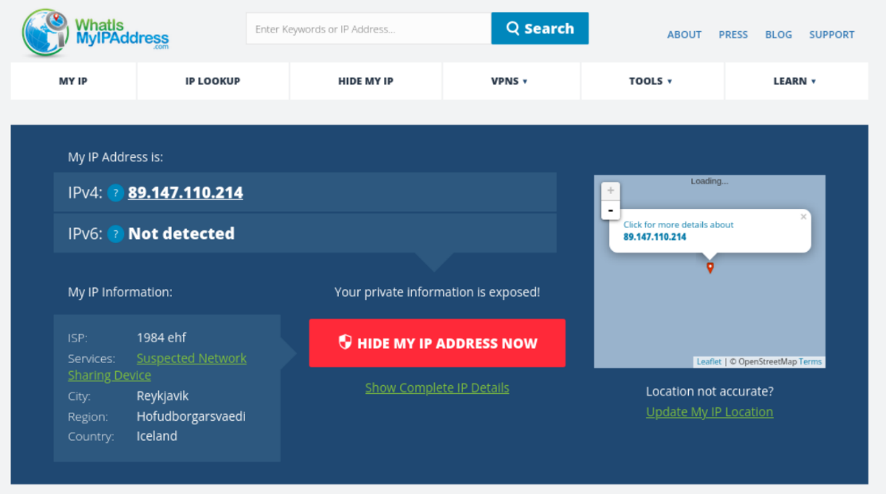

Fig .19 Tor network hided the original location

Step – 6: Let us also check DNS leak test. A DNS leak test is a tool that determines whether a user's DNS requests are being leaked or exposed outside of an encrypted VPN or proxy tunnel.

When a user visits a website or other online resource, their device sends a DNS request in order to translate the domain name into an IP address. If the DNS request is not delivered through the encrypted tunnel, the user's Internet Service Provider (ISP) can track their online activities and potentially identify their location and identity. DNS leak testing operates by mimicking DNS requests from the user's device and determining whether they are routed through the encrypted tunnel or are leaked outside of it. The test usually entails contacting a website or service that displays the user's IP address and comparing it to the IP address of the VPN or proxy server to which they are connected.

DNS leaks can occur as a result of incorrectly configured VPN or proxy settings, network connectivity problems, or software defects. DNS leak tests are useful because they assist users in identifying and correcting potential privacy and security issues, as well as selecting VPN or proxy services that do not leak DNS requests.

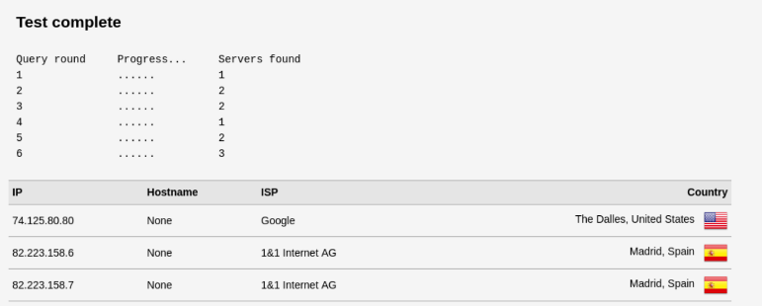

Fig .20 DNS leaks result

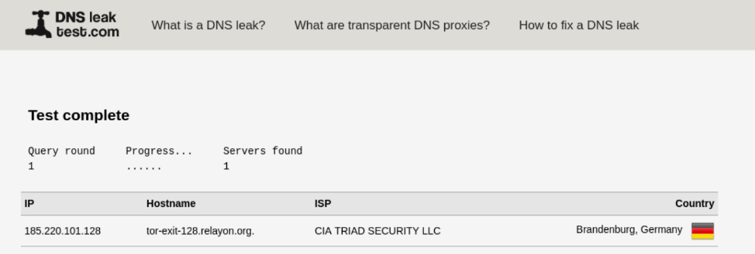

Fig .21 DNS leaks result

**CHAPTER-9**

**Hosting a TOR onion website**

Step -1: Open a terminal window on Kali Linux Install Tor by running the following command:

**$ sudo apt-get install tor**

Once Tor is installed, we can check its status by running the following command:

**$sudo service tor status**

To automatically launch Tor when Kali Linux starts up, we can add the following command in our system's startup programs:

**$sudo systemctl enable tor.service**

This will add the Tor service to the list of services that start up when Kali Linux boots. Also, we can start the Tor service manually by running the following command:

**$sudo systemctl start tor.service**

Once the service is started, we can use the Tor browser to access .onion sites and browse the web anonymously.

Step - 2: Traverse to /var/lib/tor/hidden_service and uncomment the two lines present in the location-hidden services.

HiddenServiceDir /var/lib/tor/hidden_service/

HiddenServicePort 80 127.0.0.1:8080 // Here, we are binding the port 8080 with

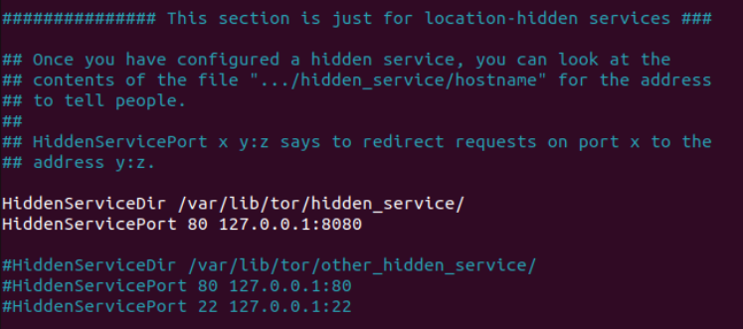

Fig .22 Modifying the Tor configuration file.

Step – 3: Start the TOR service. This can be performed just by a simple command.

$ sudo service tor start

$ sudo service tor status

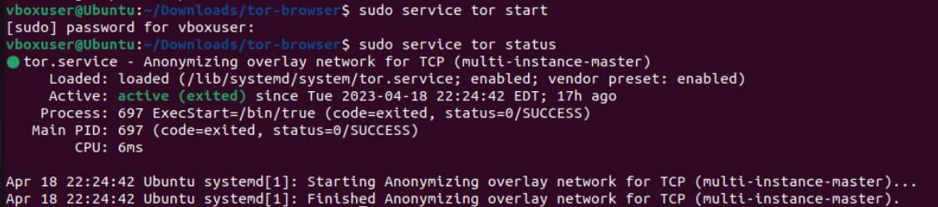

Fig .23 Enabling the Tor browser.

Step – 4: Start running the in-built python’s HTTP server and bind the IP and port with HTTP server. This can be performed by the command.

$ sudo python3 -m http.server –bind 127.0.0.1 8080

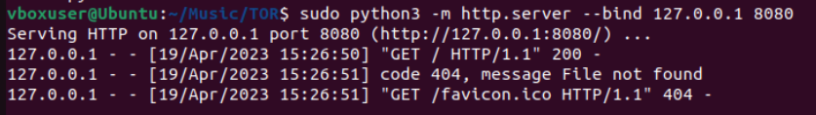

Fig .24 running the in-built python’s HTTP server.

Step -5: But we must have an address to access the site. This can be found in /var/lib/tor/hidden_service folder. Open the hostname by using the “cat” command.

Traverse to this path!

* $ cd /var/lib/tor/hidden_service

There is a file called "hostname". This is where the TOR stores the URL name for your hidden website service.

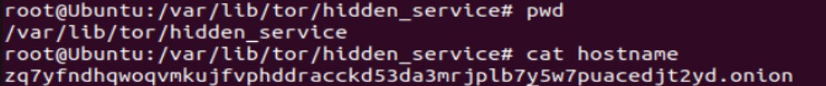

Fig .25 hidden website service.

Step – 6: Download the executable file of TOR browser from the official website and run it.



Fig .26 Downloading the executable file of TOR browser from the official website

Type in this URL onto the TOR browser.

zq7yfndhqwoqvmkujfvphddracckd53da3mrjplb7y5w7puacedjt2yd.onion

* Not only it is hosted locally, but also it can be accessed from any part of the world!
* That too for FREE!
* All you need is a TOR connection and the URL to access!

Once, we type in the URL (.onion site) in TOR browser, it automatically connects to the TOR network and accesses the .onion sites anywhere in the world.

The below image is the result of the hosted website on TOR.

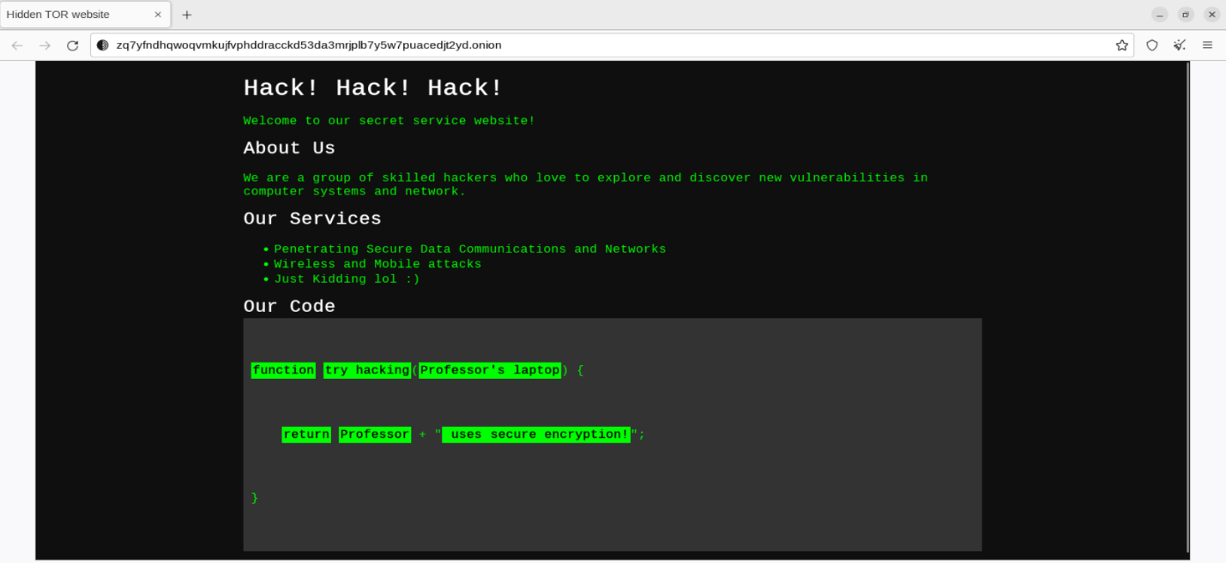

Fig. 27 Our hosted onion site

Let us once again perform IP address check and DNS leak test.

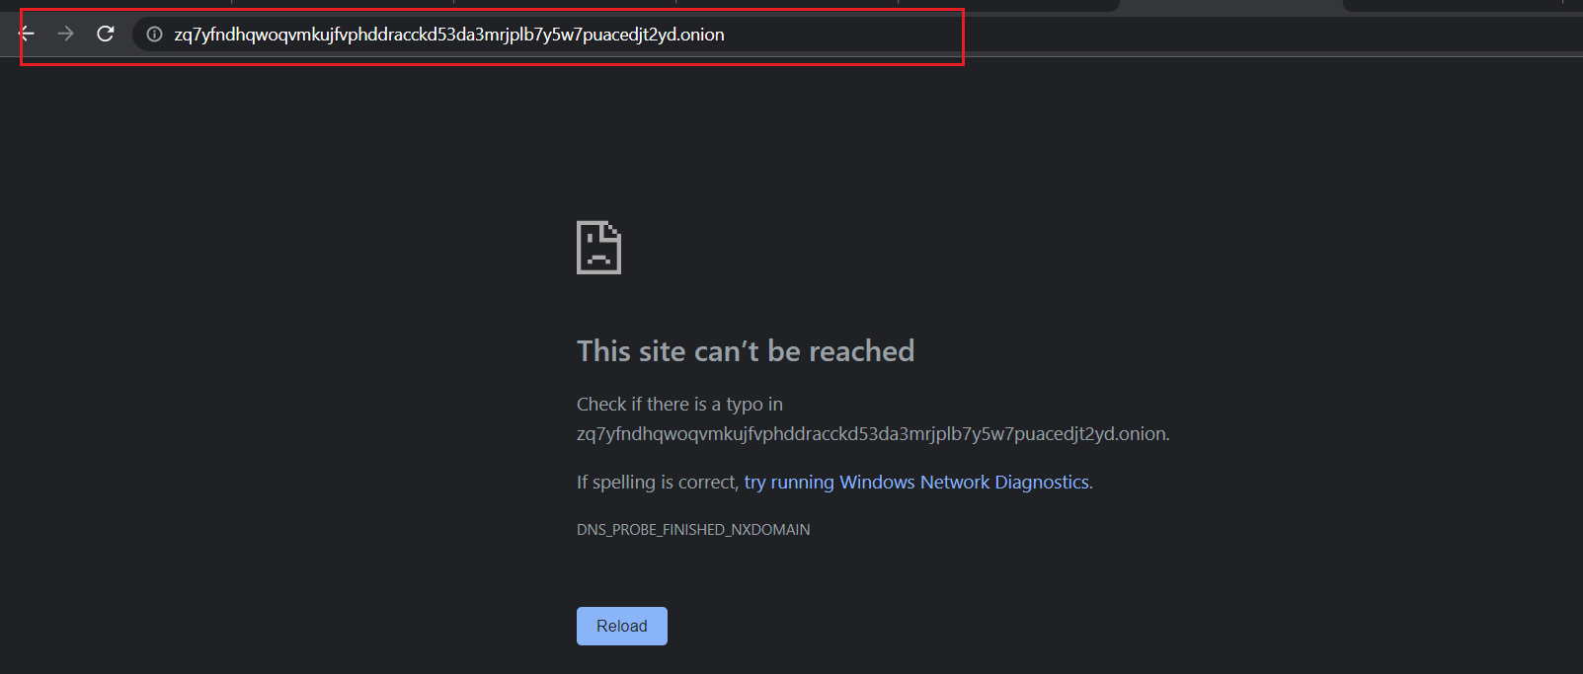

Fig .28 Access the onion website in Google Chrome.

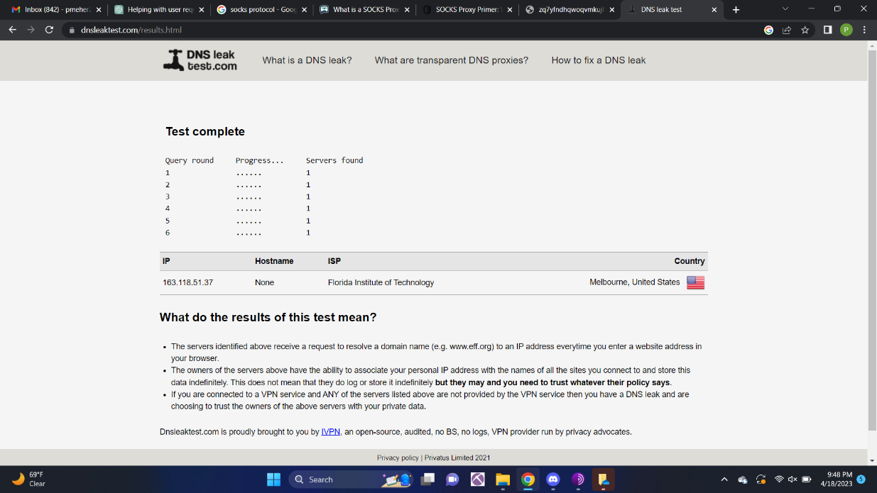

Fig .29 DNS leaks result

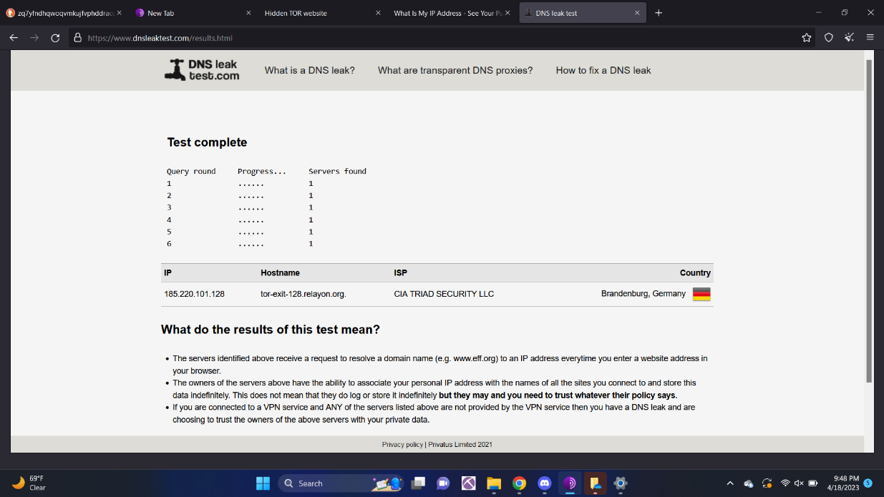

Fig .30 DNS leaks result

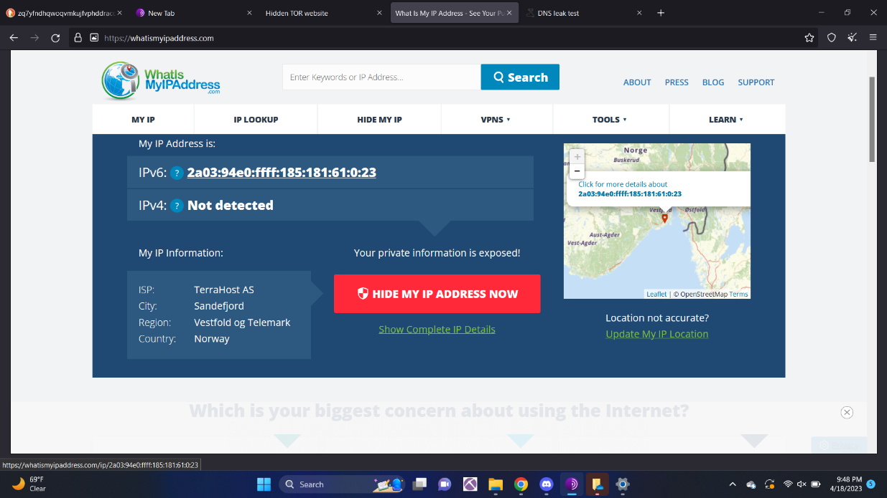

Fig .31 Tor network hided the original location

**Network Traffic analysis on published onion site**

Step – 1: Filter the HTTP packet because the onion site we published is unencrypted. This should capture the traffic when we visit the onion website. The traffic is only visible to us as this is a loopback capture. An attacker present in the network cannot view the traffic because it is not unicasted or broadcasted in the network.

In the below image, we can view the requested URI, which is the hostname, User-agent, and accept methods.

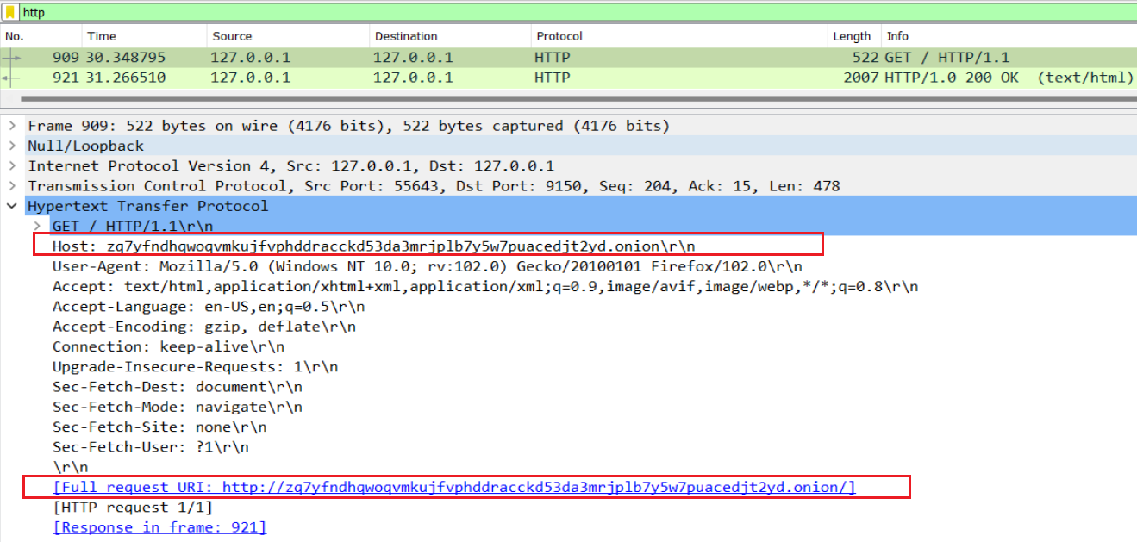

Fig. 32 Requested URI

Step – 2: Once the request is sent, we should receive the response. In this response, we can view critical information like Server name which is SimpleHTTP server by python, content-length and the response which is basically a HTML page.

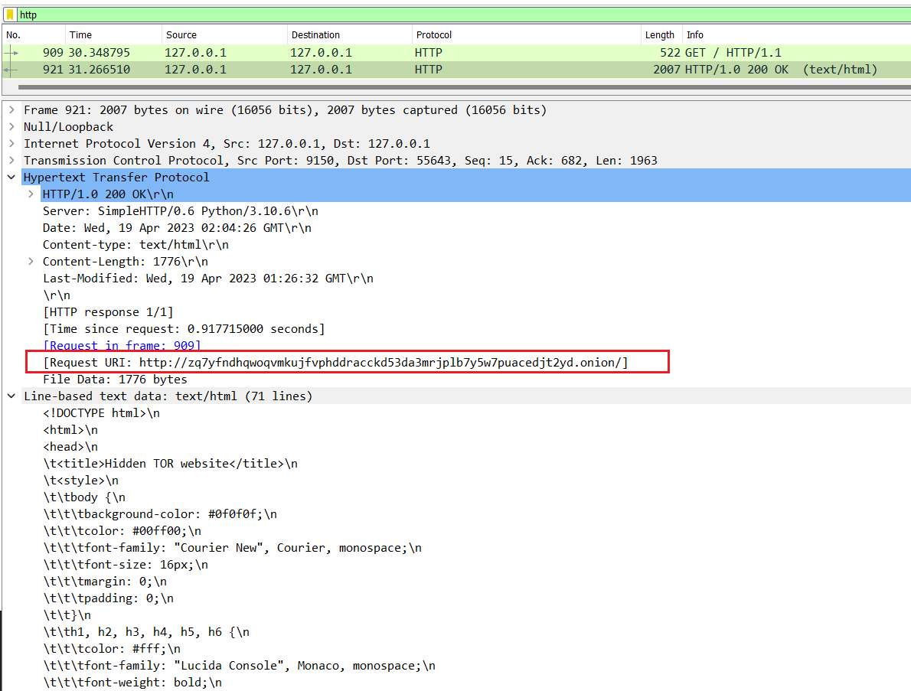

Fig. 33 Web page details captured by Wireshark.

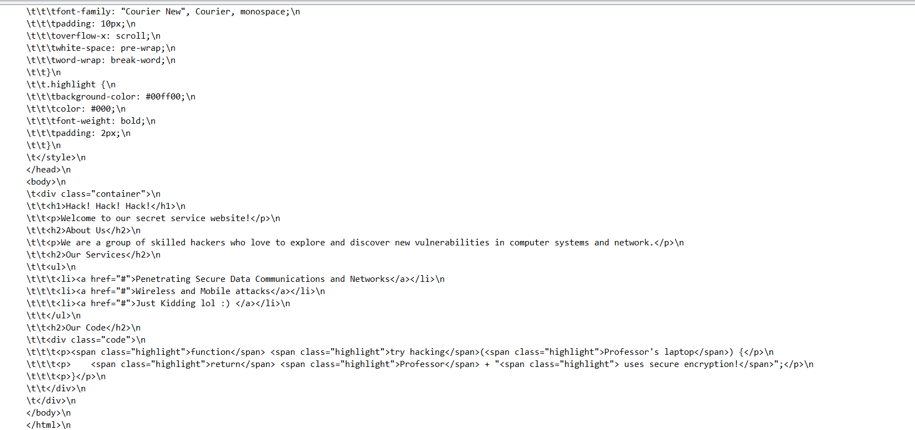

Fig. 34 Web page details captured by Wireshark.

**CHAPTER-10**

**Network Traffic Analysis of a real pcap network capture of TOR**

***Step –1:*** Import the pcap file using the Network Miner application. This should give basic information like Domain names, Web browser banners, JA3 Hashes and X.509 Certificate hashes.

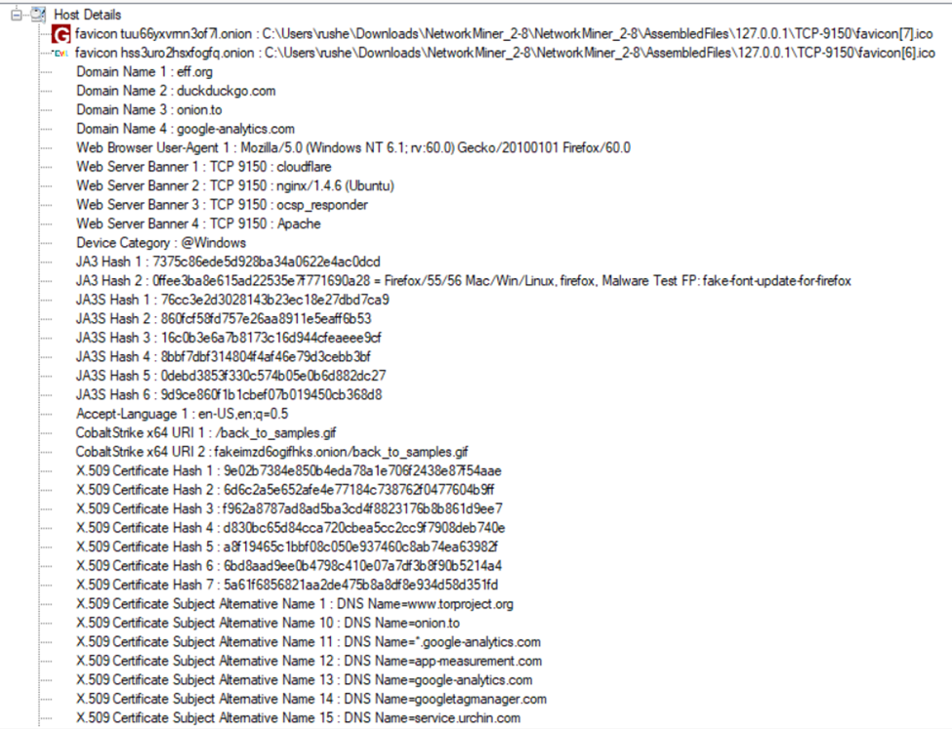

Fig. 36 Analysis of .pcap file using network miner.

***Step-2:*** Traverse to the ‘Files’ section, to view all the extracted files from the pcap.

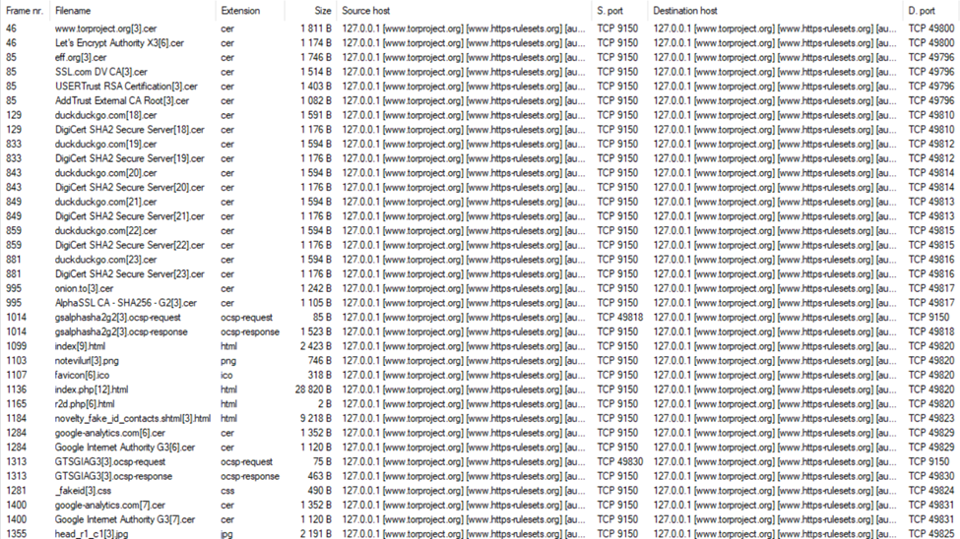

Fig. 37 All the extracted files from the pcap

***Step-3:*** We can view multiple files like HTML pages, CSS files, Image files and Certificate files. Network Miner automatically extracts every possible for us, thus making it easier than Wireshark.



Fig. 38 All the extracted files from the pcap

***Step – 4:*** We can view the html page just by double clicking on the file. By this we can know what Tyrell was browsing. Tyrell was browsing for some passports to buy. He is using a TOR network to browse these dangerous websites.



Fig. 37 Found html page in pcap

***Step – 5:*** This gives information of what types of passports tyrell was buying.



Fig. 38 Image found in .pcap files.

***Step – 6:*** Analyzing each html page from network capture so we can get further information on what Tyrell was browsing country passports like CANADA, FINLAND, UNITED KINGDOM and BRAZIL.



Fig. 40 Country passports browsed by Tyrell.



Fig. 41 Prices of different passports

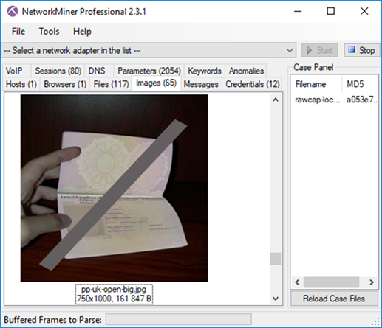

Fig. 42 overview of one of the fake passports

***Step – 7:*** Traverse to the “Credentials” section of the NetworkMiner application. We can view a lot of credential information captured during the capture. For a particular onion site, Tyrell’s username and password were captured. The username is “BadGuy Tyrell”, and password is “tyrellcorpFTW”.

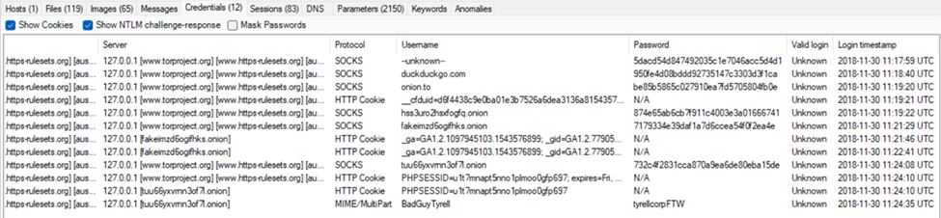

Fig. 43 User ID and password captured by network miner.



Fig. 44 Items were present in the cart from tyrell’s account.

***Step – 8:*** Open the file cart.php. This page gives details like what items were present in the cart from tyrell’s account. We can see that a Glock 19 – 9mm (about 0.35 in) gun and 100 x 9mm (about 0.35 in) bullets for Glock 19 were in the cart. This is the exact evidence in the crime scene.



Fig. 45 Transaction Mode used by Tyrell.

***Step – 9:*** It describes how Tyrell has made the transaction of buying these illegal possessions. The only source to buy these products is Bitcoin. We can view the Bitcoin wallet with bitcoin balance and Tyrell’s Bitcoin address.



Fig. 45 Transaction details of Tyrell

**CHAPTER-11**

**Conclusion**

Onion Routing is a powerful technique that provides online anonymity and privacy. While Onion Routing has some limitations, it is an important tool for anyone who values online privacy and security. There are advantages, as well as disadvantages linked to it. It gives you complete anonmyinity, but also at the same time, it’s too risky!

**References**

* Methodically Modeling the Tor Network - Rob Jansen U.S. Naval Research Laboratory [rob.g.jansen@nrl.navy.mil](mailto:rob.g.jansen@nrl.navy.mil) Nicholas Hopper University of Minnesota [hopper@cs.umn.edu](mailto:hopper@cs.umn.edu) Kevin Bauer University of Waterloo [k4bauer@cs.uwaterloo.ca](mailto:k4bauer@cs.uwaterloo.ca) Roger Dingledine The Tor [Projectarma@torproject.org](mailto:Projectarma@torproject.org)
* Shining Light in Dark Places: Understanding the Tor Network Damon McCoy1, Kevin Bauer1, Dirk Grunwald1, Tadayoshi Kohno2, and Douglas Sicker1 1 Department of Computer Science, University of Colorado, Boulder, CO 80309-0430, USA
* Critical Traffic Analysis on the Tor Network by Florian Platze, Marcel Schäfer,Martin SteinebachDarmstadt, Germany
* <https://www.netresec.com/?page=Blog&month=2018-12&post=TorPCAP---Tor-Network-Forensics>
* [https://securityintelligence.com/posts/socks-proxy-primer-what-is-socks5-and-why-should-you-use-it//](https://securityintelligence.com/posts/socks-proxy-primer-what-is-socks5-and-why-should-you-use-it/)
* <https://www.youtube.com/watch?v=GVMjk9pj2Cw>
* <https://www.antoniogioia.com/irc-with-ssl-and-otr/>
* <https://2019.www.torproject.org/docs/tor-onion-service.html.en>
* <https://www.youtube.com/watch?v=lVcbq_a5N9I>
* <https://www.youtube.com/watch?v=QRYzre4bf7I>
* <https://www.youtube.com/watch?v=ba-Eaq7hMuE>
* ChatGPt - when we had trouble setting up the website in tor :)